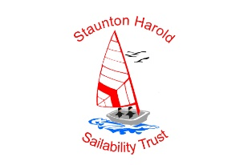SHST Powerability Certification
Certification must be carried out by PB instructor session length for Bronze level 30 minutes, Bronze and Gold 60 minutes. Boats to use can be any type suitable for the course participant.
For each level:
you must complete a number of syllabus points successfully and attend a minimum number of sessions
Certificate | Number of tasks achieved | Minimum number of sessions attended
Bronze | 5 | 2
Silver | 15 | 4
Gold | 25 | 6

Participant | Instructor | Certification Level | Date

Task | Practice date / Signature | Practice date / Signature | Practice date / Signature | Achieved
Clothing and Safety:
Decide on appropriate clothing for the conditions
Stow spare clothing
Correctly fit a buoyancy aid or life jacket
Getting Started:
Point to the instructor
Name or identify by pointing four pieces of safety equipment
Name or identify by pointing two Parts of the boat
Get onto the training boat safely
Crew Skills:
Lookout: warn the helm if there is traffic or other water users
Coil a rope
Throw a rope
Secure a rope on a cleat
Communicate with the helm
Secure and deploy a fender
Use a roving fender
Tie two nautical knots useful in powerboating
Helming Skills:
Wear the kill cord
Check the propeller is unobstructed before starting, and check for a tell-tale
Start/stop the engine using the key
Test the kill cord is working properly
Manage the throttle (personally or remotely by using voice or indication)
Engage gears smoothly and confidently
Steer a course straight ahead at displacement speed
Stop the boat
Reverse without ‘pooping’
Steer a figure of eight course
Hold off a position
Keep a good lookout using all available means (could be other people)
Communicate with the crew
Demonstrate a practical understanding of IRPCS: Head on, crossing and overtaking
Arrange the crew and equipment to trim the boat correctly

